Chapter 1: Introduction to Natural Disasters

Processes – the ways in which events, such as volcanic eruptions. Earthquakes, landslides, and floods affect Earth’s surface

* Driven by energy derived from 3 sources:
  + Internal processes (forces within Earth) : plate tectonics
  + External processes (forces on Earth’s surface): atmospheric effects and energy from the sun

Hazard – probability that a specific damaging event will happen within a particular time period

Risk – a function of the hazard, exposure, vulnerability, and coping capacity

Disaster – Hazardous event that occurs over a limited time in a define area

Catastrophe – Massive disaster that requires significant amount of money or time to recover

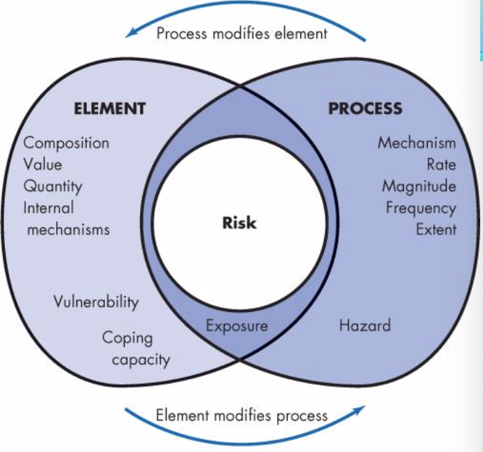

Those hazards that have great impact on human life may not cause the most property damage

Impact – function of magnitude and frequency (the size of the event and the amount of energy released)

* Also influenced by climate, geology, vegetation, population, and land use.

Magnitude-frequency concept – an inverse relationship between magnitude and frequency

Concepts & Understanding of Natural Processes and Hazards

* Through scientific investigation and analysis (scientific method)
  + Past history, patterns in their occurrence and types of precursor events
* Evaluation of risk (risk analysis)
* Linkage between hazards and the environment
* Population growth and socio-economic changes increase the risk from natural hazards
* Damage and loss of life from natural disasters can be reduce

Science and Natural Disasters

* Scientific method: through investigations and experiments, subject to verification
* Hypothesis: a possible answer to a question and is an idea that can be tested and therefore accepted or rejected
* Allows for identification of where hazards occur, their magnitude and frequency
* We can to a degree control some hazards, but mainly beyond our control

Prediction – involves specifying the date, time and magnitude of the event

Forecast – is less precise and has a range of probability for the event

(some hazards can be predicted but most forecasted)

Hazard Reduction

* Identify the location of a probable event
* Determine the probability of the event
* Identify any precursor events
* Forecast or predict the event
* Issue a warning to the public

An understanding of hazardous processes is vital to evaluating risk.

* Risk = probability of event \* consequences
* Consequences: deaths and injuries, damage to property, economic effects, etc
* Acceptable risk: the amount of risk that an individual or society is willing to take (different levels of tolerance)

Hazards are commonly linked to each other and to the environment in which they occur

* Some events may cause others
* The physical environment is the link to hazards

Population Growth and socio-economic changes increase the risk from natural hazards

* Concentration of population creates greater loss of life in a disaster
* Exponential human population growth puts greater demand on Earth’s resources
* Most people in developing countries lack the resources to protect themselves from hazardous events (typically catastrophic) while in developed countries, economic costs is higher than deaths

Damage and loss of life from Natural Disasters can be reduced

* Direct effects: people killed, building damaged, etc
* Indirect effects: crop failures, starvation, emotional distress, loss of employment, etc
* Recovery from disaster (reactive):
  + Emergency work
  + Restoration of services and communication lines
  + Reconstruction
* Avoiding and adjusting to hazards (proactive)
  + Land use planning (ex. Not building on a floodplain)
  + Insurance/reinsurance
  + Evacuation
  + Disaster preparedness
  + Artificial control (ex.seawalls, channelization, etc)

Natural Services Function: the same natural events that injure people and destroy property also provide important benefits

* Ex. Volcanoes create new land
* Ex. Floods provide nutrients for soil
* Ex. Earthquakes contribute to mountain building